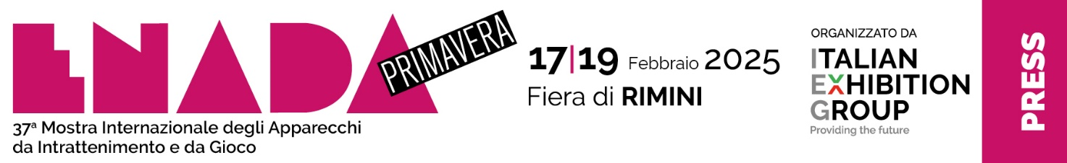
press release no. 5

ENADA primavera 2025
SERVICES GUIDE

Rimini Expo Centre from 17-19 February

Rimini, 30 January 2025 - Visiting the Rimini Fair and staying in the Rimini area is now easier than ever, thanks to the services tailored to operators and the public of ENADA Primavera 2025.

► ACCESSING THE EXPO CENTRE: Access ENADA from the SOUTH entrance. Occupied halls: D1, D2, and D3.

► EVENT TIMES: 10:00-18:00; last day: 10:00-15:00

► TICKET OFFICE: exclusively for professional operators. Paid admission.
Full ticket at the box office: €30, reduced ticket online: €25.
Enada Primavera and Rimini Amusement Show are B2B trade fairs; all operators must provide proof of their professional sector affiliation, such as a business card, membership card, business license, or other document attesting to their activity. Minors are not permitted.
New: from February 16th to 18th, alongside Enada Primavera, IEG's Beer&Food Attraction, The Eating Out Experience Show, will take place, showcasing the world of dining out.
If you have an Enada Primavera ticket, you can easily purchase a Beer&Food Attraction ticket at the cashier for just €2 (and viceversa).

► HOW TO GET HERE: The expo centre is easily accessible via the A14, the Bologna-Bari-Taranto motorway. The venue is situated just 4 kilometres from both the Rimini Sud and Rimini Nord exits. Find the shortest driving route at https://www.enada.it/enada/info-utili/come-arrivare

► SHUTTLE BUS AND TRAINS: The train station at IEG - Fiera di Rimini, located right at the SOUTH entrance of the district, will be operational every day of the event. Public buses - number 9 (from Rimini station), number 10 (from Rimini Sud/Miramare), and number 5 (from Rimini Nord/Torre Pedrera).
For more information on public transportation schedules, visit: https://www.enada.it/visita/enada-primavera/come-arrivare

►BOOKING ACCOMMODATION: You can easily book your hotel online at https://www.enada.it/enada/info-utili/prenota-hotel

►DISABLED VISITORS: Rimini Expo Centre provides easy access and convenient use of the exhibition centre for those with disabilities, offering the necessary services at https://www.enada.it/enada/info-utili/accessibilita

ABOUT ENADA 2025
Date: 17-19 February 2025; organiser: Italian Exhibition Group S.p.A., in collaboration with SAPAR; edition: 37th; recurrence: annual; info: https://www.enada.it/

ABOUT RAS 2025
Date: 17-19 February 2025; organiser: Italian Exhibition Group S.p.A., in collaboration with SAPAR; edition: 7th; recurrence: annual; info: https://www.riminiamusement.it/

ITALIAN EXHIBITION GROUP PRESS CONTACTS
head of media relations & corporate communication: Elisabetta Vitali; press office manager: Marco Forcellini, Pier Francesco Bellini; international press office coordinator: Silvia Giorgi; press office coordinator: Luca Paganin; press office specialist: Nicoletta Evangelisti, Mirko Malgieri: media@iegexpo.it

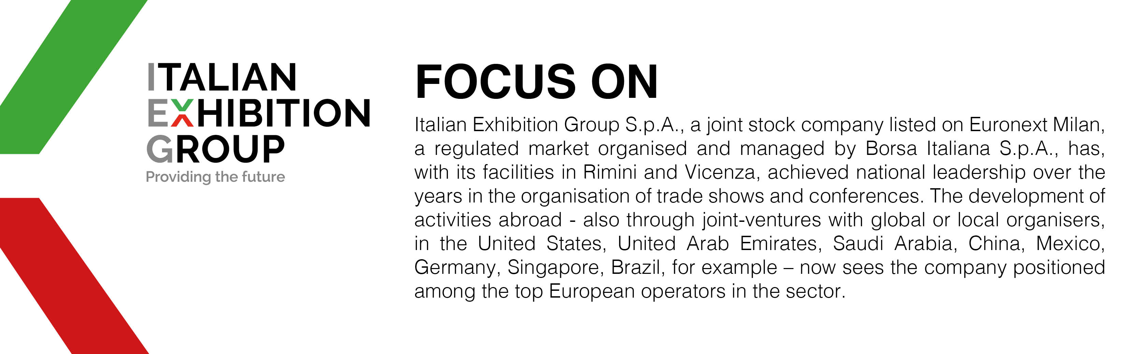

This press release contains forecast elements and estimates that reflect the management’s current opinions (“forward-looking statements”), particularly regarding future management performance, realization of investments, cash flow trends and the evolution of the financial structure. For their very nature, forward-looking statements have a component of risk and uncertainty, as they depend on the occurrence of future events. The effective results may differ (even significantly) from those announced, due to numerous factors, including, only by way of example: food service market and tourist flow trends in Italy, gold and jewellery market trends, green economy market trends; the evolution of raw material prices; general macroeconomic conditions; geopolitical factors and evolutions in the legislative framework. Moreover, the information contained in this release does not claim to be complete, and has not been verified by independent third parties. Forecasts, estimates and objectives contained herein are based on the information available to the Company as at the date of this release.

